Day in the Life of the Hudson River 10/13/22
Riverfront Green, Peekskill
RIVER MILE: 43.5
Salt Front: ~ RM76
Walter Panas High School- Michael Billy, 7 students & 1 adults
Latitude 41.20299 N & Longitude – 73.95778 W
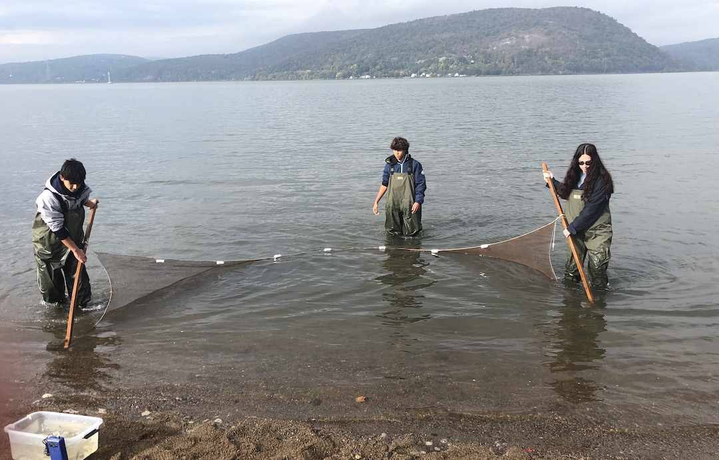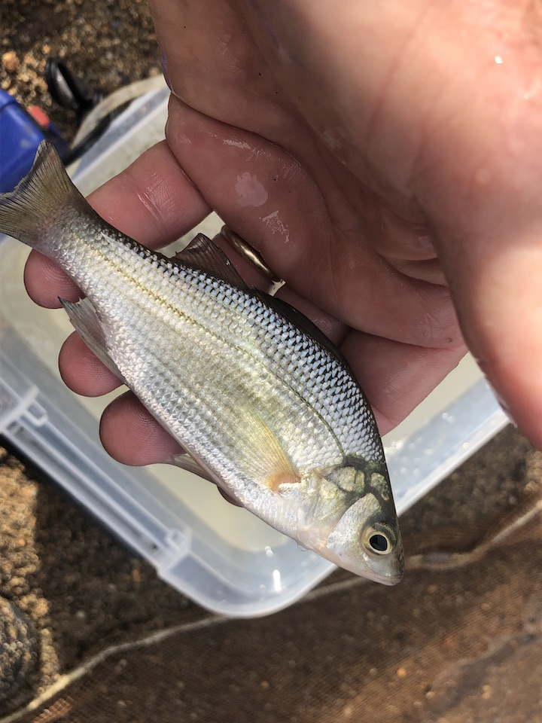
Location: Riverfront Green, Peekskill, Westchester County, NY
Area: Grassy, park area with sandy beachfront, pier, used for picnics, boating, and fishing
Surrounding Land Use: 50% grassy park; 40% industrial/commercial; 10% beach
Sampling Site: Beach with brick, charcoal, slag, and concrete bulkhead
Shoreline: Rocky, sandy, muddy with pebbles
Water: 2 ft
River Bottom: Rocky
*NR = Not read/recorded
ITEM |  | Time |  | Reading |  |  |  | Comments
Physical
Air Temperature |  | 8:00 AM |  | 12° C |  |  | ^{54°F}
Wind Speed: |  | 8:00 AM |  | Anemometer  0 |  |  | Beaufort  0 | Direction
Weather today |  | 8:00 AM |  | > 75% cloud cover |  |  | Start & Stop Rain
Weather the past 3 days: |  | NR
Tides- |  | Time |  | Rising, Falling, Unchanged |  |  | Water Height (cm)
 |  | 8:00 AM- 10:30 AM |  | Slack  Rising |  |  | 9 cm  79 cm
Current- |  | Time |  | Cm/sec |  | Knots | North/South | Ebb/Flood/Still
 |  | 8:30 AM  10:30 AM |  | NR |  | NR | NR | Flood  Flood
Water Temperature- |  | 8:10 AM |  | 16.8°C |  |  | 62º F
Turbidity- Long sight tube (120 cm) |  | 9:05 AM |  | 37.8 cm |  |  | Conditions were wavy
Chemical
Salinity- HR Quantabs |  | 8:15 AM |  | 7.8 quantab units HR |  |  | 3079 ppm Cl- | 5,562 ppm Total Sal.
Standardized Salinity – HR Quantab |  | NR
DO – Chemet’s Kit |  | Time  8:46 AM |  | Temp  16.8°C |  |  | ppm DO  7 | % saturation  70%
pH – Color Match Kit |  | 8:40 AM  10:58 AM |  | 7.5  7.5
Nitrates- NR
Phosphates- NR
Alkalinity- NR
Biological
Fish – Seine |  | Number |  | Name |  |  | Length of longest | Length of smallest
9:30- 11:30 AM |  | 2  29  6  14 |  | Spottail Shiner  Atlantic Silverside  White Perch  Striped Bass |  |  | 9 cm  12 cm  15 cm  7 cm | -  10 cm  6 cm  6 cm
Fish Totals |  | TOTAL: 51 |  | Diversity: 4
Macroinvertebrates |  | Number |  | Name |  |  | Length of longest | Length of smallest
Macroinvertebrate Totals |  | TOTAL: 0 |  | Diversity: 0
Sediment Core -
Length | H2S smell |  | Oxid Top |  | Oil |  | Grain Size | Other Features
7.5 cm | No |  | No |  | No |  | Abundant: sand, gravel, pebbles  Common: mud | Rare: shells, coal, slag
Boats-NR
 | Time |  | Name |  | Color |  | North/Southbound | Light/Loaded
Commercial
Residential

